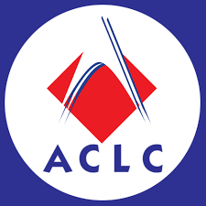
ACLC COLLEGE OF ORMOC
BRGY. COGON, ORMOC CITY LEYTE
BACHELOR OF SCIENCE AND TECHNOLOGY IN INFORMATION TECHNOLOGY
School Year 2023-2024

Rocket Launcher
Calculus Based Physics
Members :
Bugtai
Arcillas
Impoc
Otadoy
Permeho
Claros
Florendo
Dano
Sambajon
Son
Robles
Intrustor: Kingsley Mendoza Matugas
1st Semester 2023-2024
- DOCUMENTARY REPORT

- Steps \ Contruction
Step1 : Prepare the Equipment Need
.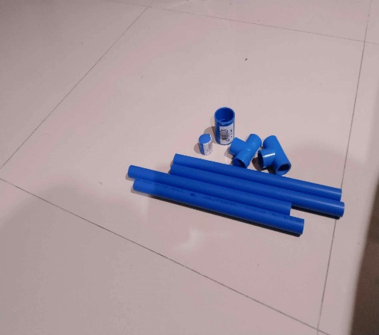
Step 2: Now Make it sturdy by using PVC Solvent
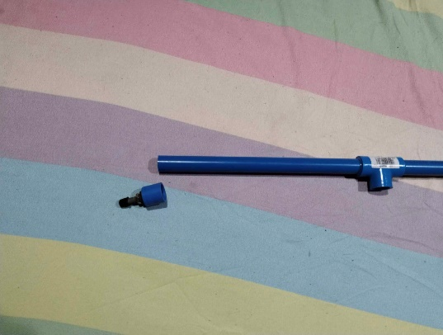
Step 3: Now Make it sturdy again by using PVC Solvent
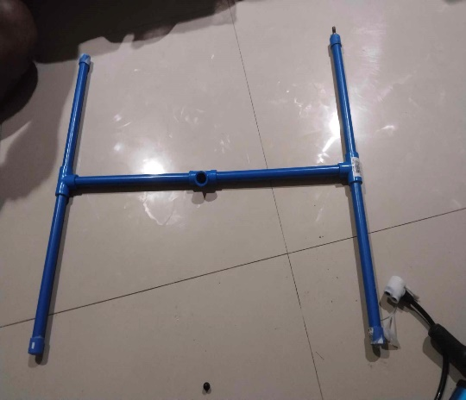

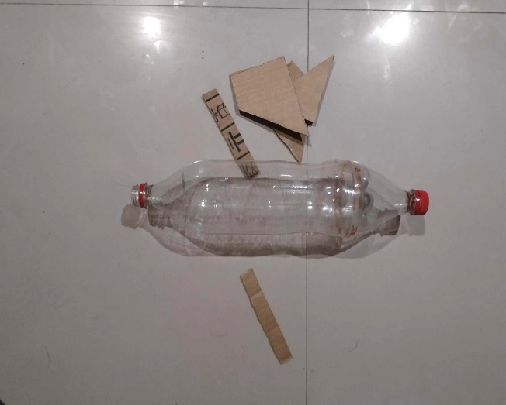
Step 4 : Now prepare every equipment needed to form the Rocket.

Step 5: Now use JnT Tape for Shaping the wings and use shoe glue for the wings to be sturdy.
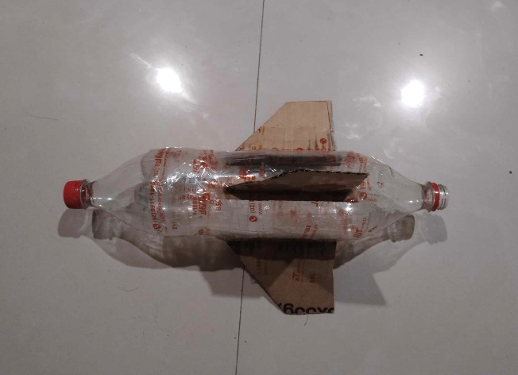

- Lists of Materials
- Coupling Blue
- PVC Solvent
- Nylon Black
- Pipe Accs Emerald
- Pipe Accs Emerald Cap
- Cap PVC
- White Spray Paint
- Hose Clamp Thalus
- !.5 Liter Coke

- Receipt \ Cost
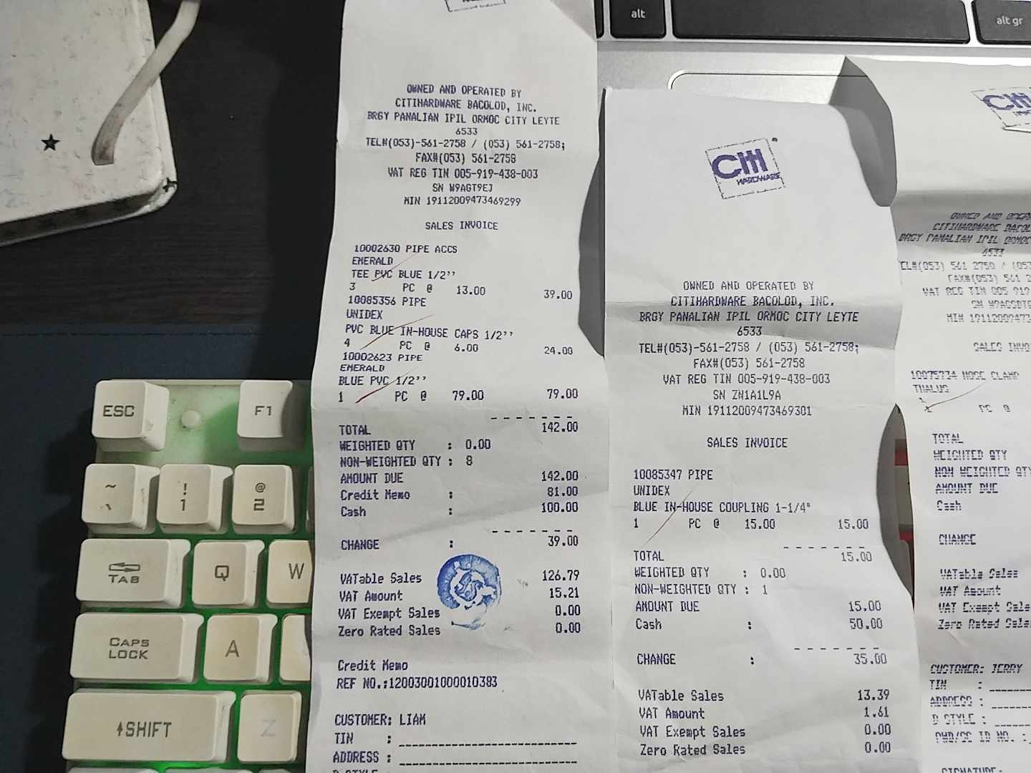
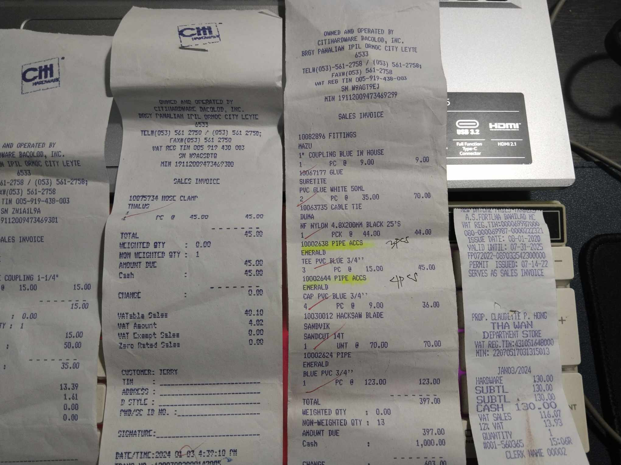

- Analysis of the Concept – Projectile Motion
- Based on how the rocket and the rocket launcher coorperate with each other shows it can be successful launch. Given the fact that it was very low in range on the 1st-2nd attempt upon launching the rocket with a strong pressure.
- In the break time we are given 5 minutes to prepare for the 3rd attempt to launch and I realized that from the 1st and 2nd attempt the rocket lacks the weight to have a strong front to hold the position while on the air.
- In the end we have a miracle launch by having a range as one basketball court and half a volleyball court, and the reason is that it glide to the air.
- Lastly, our launcher was I thought a wrong angle because other use 45 degrees but I use 60 degrees and luckily it was really good pair with our rocket because our rocket depends on how high it will launch and to depend in the air current.

- Conclusion

The analysis of launching a water bottle rocket in a open area in the ACLC College of Ormoc underscores the interdisciplinary nature of the activity.
Also it was expected to perform a good launch based on how it was built but in the end it was successful. It shows how the principles of physics, addressing environmental challenges, implementing safety measures, and recognizing educational benefits contribute to a comprehensive understanding of this experiment. Whether conducted in educational settings or as a recreational activity, launching water bottle rockets on a open area offers a dynamic and enriching experience that combines science, practical skills, and teamwork.

Message to sir: Sir it was a great and fun experience that as being an BSIT student but out of our instruction that is currently teaching us, only 2 instructors really get our attention to learn and your one of the 2 instructors, keep it up sir hope we see again in 2nd semester – group 2

